EXPERIMENT 1

IMPLEMENTATION OF CAESAR CIPHER ENCRYPTION AND DECRYPTION

AIM
To implement the Caesar Cipher algorithm for the encryption and decryption of plaintext using a fixed shift key.

ALGORITHM
Encryption
Step 1: Start the program.
Step 2: Read the plaintext from the user.
Step 3: Read the shift key value.
Step 4: Traverse each character of the plaintext.
Step 5: If the character is an alphabet, encrypt it by shifting it forward using the key value with modulo 26.
Step 6: If the character is a space or special character, keep it unchanged.
Step 7: Store the encrypted characters to form the ciphertext.
Step 8: Display the encrypted text.
Decryption
Step 9: Traverse each character of the ciphertext.
Step 10: Use the same shift key for decryption.
Step 11: If the character is an alphabet, decrypt it by shifting it backward using the key value with modulo 26.
Step 12: If the character is a space or special character, keep it unchanged.
Step 13: Store the decrypted characters to reconstruct the original plaintext.
Step 14: Display the decrypted text.
Step 15: Stop the program

CODE:
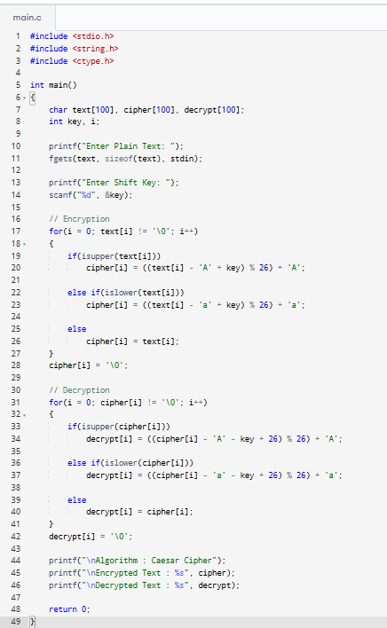
OUTPUT:
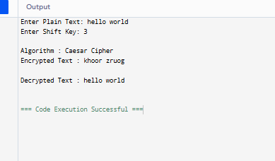
RESULT
Thus, the Caesar Cipher encryption and decryption algorithm was successfully implemented using the C programming language. The plaintext was encrypted using the specified shift key, and the original plaintext was successfully recovered through the decryption process
EXPERIMENT 2

IMPLEMENTATION OF MONOALPHABETIC SUBSTITUTION CIPHER ENCRYPTION AND DECRYPTION

AIM
To implement the Monoalphabetic Substitution Cipher algorithm for encryption and decryption of plaintext using a substitution key.
ALGORITHM
Encryption
Step 1: Start the program.
Step 2: Read the plaintext from the user.
Step 3: Define the substitution key.
Step 4: Traverse each character of the plaintext.
Step 5: Replace each alphabet with its corresponding character in the substitution key.
Step 6: Keep spaces and special characters unchanged.
Step 7: Display the encrypted text.
Decryption
Step 8: Traverse each character of the encrypted text.
Step 9: Find the corresponding character in the original alphabet.
Step 10: Keep spaces and special characters unchanged.
Step 11: Display the decrypted text.
Step 12: Stop the program

CODE
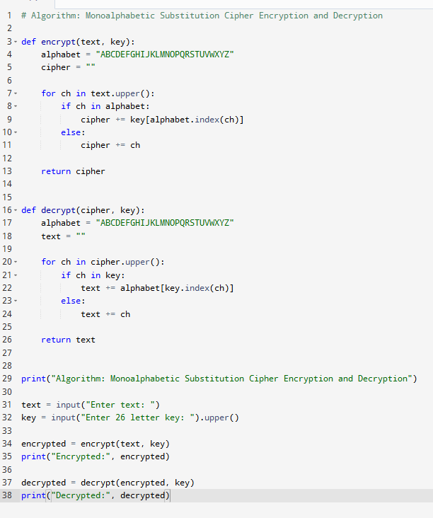
OUTPUT
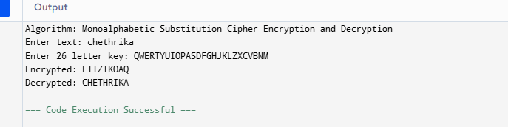

RESULT
Thus, the Monoalphabetic Substitution Cipher encryption and decryption algorithm was successfully implemented using the C programming language. The plaintext was encrypted using the substitution key and successfully decrypted to obtain the original plaintext
EXPERIMENT 3

IMPLEMENTATION OF POLYALPHABETIC (VIGENÈRE) CIPHER ENCRYPTION AND DECRYPTION

AIM
To implement the Polyalphabetic (Vigenère) Cipher algorithm for encrypting and decrypting a message using a keyword.
ALGORITHM
Encryption
Step 1: Start the program.
Step 2: Read the plaintext from the user.
Step 3: Read the keyword.
Step 4: Repeat the keyword until it matches the length of the plaintext.
Step 5: Traverse each character of the plaintext.
Step 6: If the character is an alphabet, encrypt it using the corresponding character of the repeated keyword.
Step 7: If the character is a space or special character, keep it unchanged.
Step 8: Store the encrypted characters to form the ciphertext.
Step 9: Display the encrypted text.
Decryption
Step 10: Traverse each character of the ciphertext.
Step 11: Use the same repeated keyword for decryption.
Step 12: If the character is an alphabet, decrypt it using the corresponding keyword character.
Step 13: If the character is a space or special character, keep it unchanged.
Step 14: Store the decrypted characters to reconstruct the original plaintext.
Step 15: Display the decrypted text.
Step 16: Stop the program.

CODE
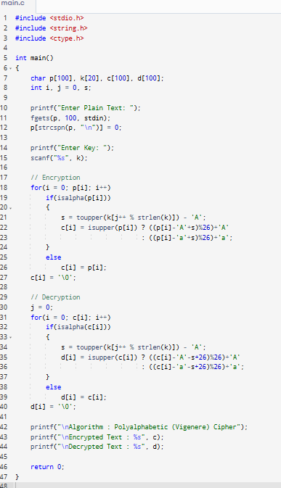
OUTPUT
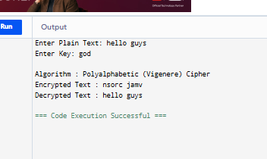
RESULT
Thus, the Polyalphabetic (Vigenère) Cipher encryption and decryption algorithm was successfully implemented using the C programming language. The plaintext was encrypted using the given keyword, and the original plaintext was successfully recovered through the decryption process. Hence, the correctness of the algorithm was verified
EXPERIMENT 4

IMPLEMENTATION OF HILL CIPHER ENCRYPTION AND DECRYPTION

AIM
To implement the Hill Cipher algorithm for encrypting and decrypting a message using a 2 × 2 key matrix.
ALGORITHM
Encryption
Step 1: Start the program.
Step 2: Read the plaintext from the user.
Step 3: Read the 2 × 2 key matrix.
Step 4: Convert each plaintext character into its numerical equivalent (A = 0, B = 1, ..., Z = 25).
Step 5: Divide the plaintext into blocks of two characters.
Step 6: Multiply each plaintext block by the key matrix and apply modulo 26.
Step 7: Convert the resulting numerical values back into alphabets.
Step 8: Display the encrypted text.
Decryption
Step 9: Read the inverse of the key matrix modulo 26.
Step 10: Convert the ciphertext into numerical values.
Step 11: Multiply each ciphertext block by the inverse key matrix and apply modulo 26.
Step 12: Convert the resulting numerical values back into alphabets.
Step 13: Display the decrypted text.
Step 14: Stop the program.

CODE
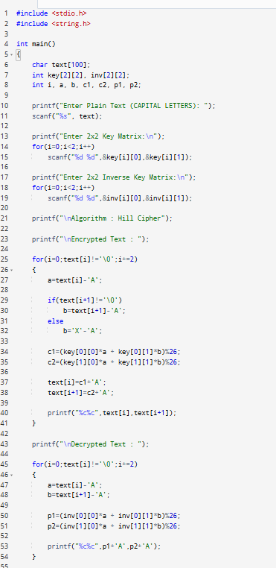
OUTPUT
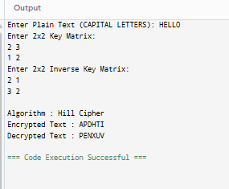
RESULT:
Thus, the Hill Cipher algorithm was successfully implemented for both encryption and decryption, and the results were verified successfully..

EXPERIMENT 5

IMPLEMENTATION OF HILL CIPHER ENCRYPTION AND DECRYPTION

AIM
To implement the Playfair Cipher algorithm for encryption and decryption of a message using a keyword.
ALGORITHM
Step 1: Start.
Step 2: Read the keyword and plaintext.
Step 3: Create a 5 × 5 key matrix using the keyword (merge I/J).
Step 4: Convert the plaintext to uppercase and remove spaces.
Step 5: Replace J with I.
Step 6: Divide the plaintext into pairs.
Step 7: Insert X between repeated letters and add X if the last pair is incomplete.
Step 8: Encrypt each pair:
- Same row → Replace with the letter to the right.
- Same column → Replace with the letter below.
- Different row and column → Apply the rectangle rule.
Step 9: Combine all encrypted pairs to get the ciphertext.
Step 10: Decrypt using the reverse rules:
- Same row → Letter to the left.
- Same column → Letter above.
- Rectangle → Apply the rectangle rule.
Step 11: Display the encrypted and decrypted text.
Step 12: Stop.
CODE
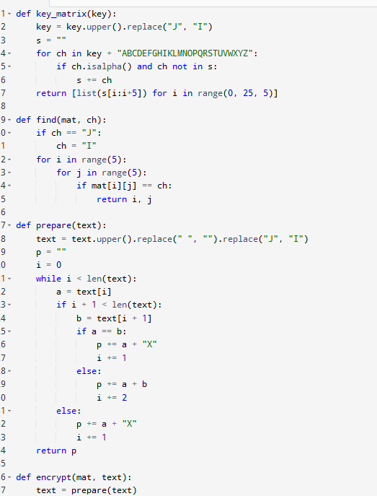
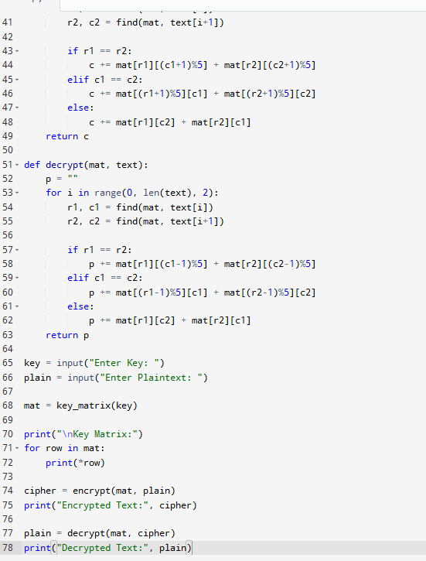
OUTPUT
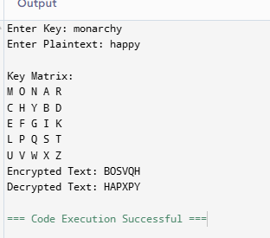

RESULT
Thus, the Playfair Cipher algorithm was successfully implemented, and the given plaintext was encrypted and decrypted using the specified keyword.
EXPERIMENT 6

IMPLEMENTATION OF RAIL FENCE CIPHER ENCRYPTION AND DECRYPTION

AIM:
To implement Rail Fence Cipher algorithm for encryption and decryption of a given message.
ALGORITHM:
Encryption:
Step 1: Start the program.
Step 2: Read the plaintext and number of rails.
Step 3: Place the plaintext characters in a zigzag pattern across the rails.
Step 4: Read the characters row by row from the rails.
Step 5: Generate and display the ciphertext.
Decryption:
Step 1: Start the program.
Step 2: Read the ciphertext and number of rails.
Step 3: Create an empty zigzag pattern with the given rails.
Step 4: Mark the positions of characters in the zigzag pattern.
Step 5: Fill the marked positions with ciphertext characters row by row.
Step 6: Read the characters in zigzag order to obtain the plaintext.
Step 7: Display the decrypted message.
Step 8: Stop the program.

CODE
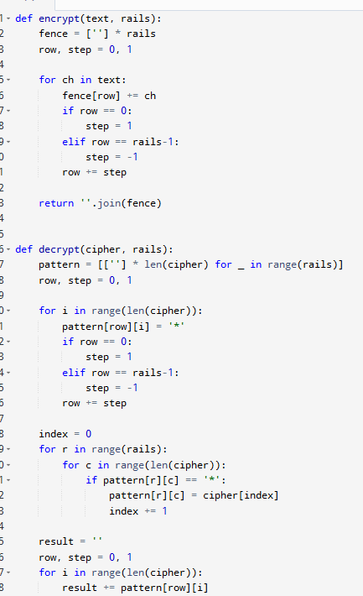
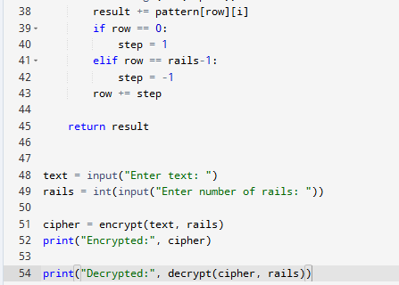

OUTPUT
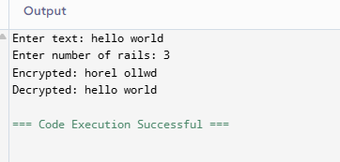

RESULT:
Thus, the Rail Fence Cipher encryption and decryption was implemented successfully.
EXPERIMENT 7

IMPLEMENTATION OF COLUMNAR TRANSPOSITION CIPHER ENCRYPTION AND DECRYPTION

AIM:
To implement Columnar Transposition Cipher algorithm for encryption and decryption of a given message.
ALGORITHM:
Encryption:
Step 1: Start the program.
Step 2: Read the plaintext and key from the user.
Step 3: Arrange the plaintext characters into rows according to the key length.
Step 4: Arrange the columns based on the alphabetical order of the key.
Step 5: Read the characters column by column to generate the ciphertext.
Step 6: Display the encrypted message.
Decryption:
Step 1: Start the program.
Step 2: Read the ciphertext and key from the user.
Step 3: Calculate the number of rows and columns using the key length.
Step 4: Arrange the ciphertext characters into columns according to the key order.
Step 5: Read the characters row by row to obtain the plaintext.
Step 6: Display the decrypted message.
Step 7: Stop the program.

CODE
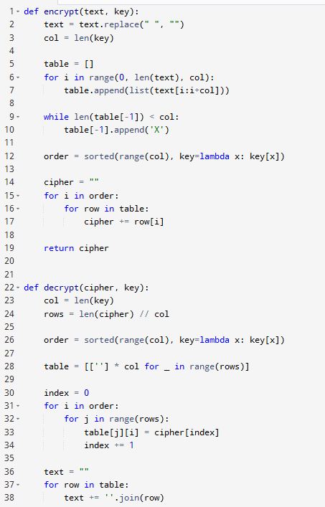
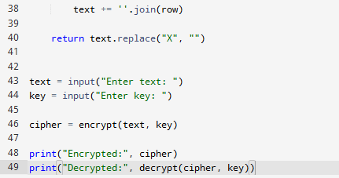
OUTPUT
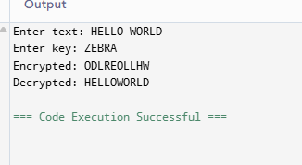

RESULT:
Thus, the Columnar Transposition Cipher encryption and decryption was implemented successfully. The given plaintext was converted into ciphertext using columnar technique.
The original plaintext was obtained successfully after decryption.

